Employees who handle cash are expected to be careful, accurate and to settle their funds each day without overages or shortages. We recognize the possibility that differences may occur from time-to-time and we have developed the following recommended procedures.
- Departments are responsible for complying with the policies and procedures for cash handling and depositing outlined on the Office of the Bursar website www.bursar.uconn.edu.
- Regardless of amount, if the shortage is the result of a suspected or documented theft, the shortage must be reported immediately to the Bursar, Controller, and University Police. The results of the investigation will determine the subsequent actions. See also the “Policy on the Prevention and Reporting of Fraud and Fiscal Irregularities” at http://policy.uconn.edu/?p=6794.
- Violations of this policy may result in appropriate disciplinary measures in accordance with University By-Laws, General Rules of Conduct for All University Employees, applicable collective bargaining agreements, and the University of Connecticut Student Conduct Code.

When over/short occurs

In Change Fund

Over
- Notify Cash Operations
- Any overage should be deposited to a department account using the over/under object code 1122 at least weekly by submitting a CR in KFS and delivering to Cash Operations.

Short - unexplained loss, counterfeit bill, etc.
- Submit Accountability Form C1 on Controller’s website to report loss.
- Notify Cash Operations
- Submit DV using object code 1122 to replenish change fund/cash on hand attaching form C1 and Over/Under Form as backup.

In Daily Deposit

Over-
- Notify Cash Operations
- Initiate CR in KFS with a second line to credit the overage using department KFS account and 1122 object code.

Short - unexplained loss, counterfeit bill, etc.
- Notify Cash Operations
- Initiate CR in KFS to record full revenue for that day. For example, if you should have received $500, the accounting lines should have one line with the full amount of revenue for that day, and then a second line with the shortage hitting object code1122 (over/under)

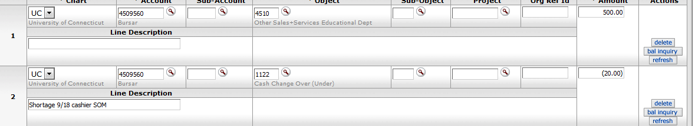

- Attach Over/Under Form in the notes section of the edoc.

Clearing out object code 1122
- On a quarterly basis, Cash Operations will review activity in the 1122 object code and follow up with departments as needed.
- Cash Operations will submit a DI to record any losses as an expense (7055). Any overage would be credited to the General Scholarship Fund 6342050-4865.

